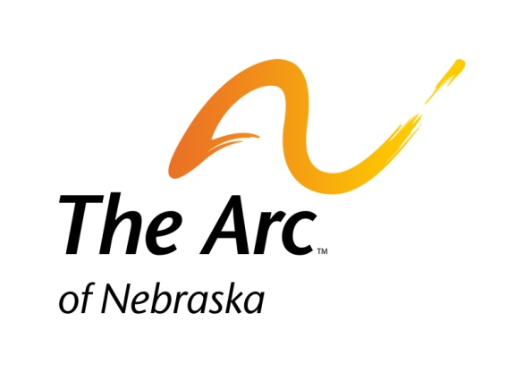

**Sponsorship Agreement**

______________________________________________

(Name of Organization)

will partner with The Arc of Nebraska to sponsor

48thAnnual Senatorial Dinner

Wednesday, February 8, 2018

|  |  |
| --- | --- |
| **□ PLATINUM SPONSOR - $800**   * 8 meals * Booth for sharing information and notable accomplishments with guests * Complimentary 8 x 10 sign displayed on partnership wall* * Business card size ad in program* * Business name listed in program * Name on website event page * Verbal Recognition at Event   **□ GOLD SPONSOR - $500**   * 5 meals * Complimentary 8 x 10 sign displayed on partnership wall * Business card size ad in program* * Business name listed in program * Name on website event page * Verbal Recognition at Event | **□ SILVER SPONSOR - $200**   * 2 meals * Business card size ad in program* * Business name listed in program * Name on website event page * Verbal Recognition at Event   **□ BRONZE SPONSOR - $100**   * 1 meal * Business name listed in program * Name on website event page * Verbal Recognition at Event   *$10 set-up fee if an electronic file is not available  Please include name of persons attending and meal choices below. Meal choices: pork, chicken, or pasta |

Name/meal choice:

1. _______________________________________ 5. ____________________________________

2. ________________________________________ 6. ____________________________________

3. ________________________________________ 7. ____________________________________

4. ________________________________________ 8. ____________________________________

Contact Person: ________________________________________________________________

Telephone Number: _____________________ E-mail Address: __________________________

Address: ______________________________ City: _______________ Zip Code: __________

Please mail form and check to:

The Arc of Nebraska

215 Centennial Mall South, Suite 508 ● Lincoln, NE 68508

402-475-4407 Phone 888-519-6524 Fax

[info@arc-nebraska.org](mailto:info@arcnebraska.org)