Directions and Parking for the Storz Pavillion Banquet Room #1 & 2

Storz is off of 42 Street between Farnam (to the North) and Emile (to the South). You can valet or park your car on your own in the lot immediately in front of the Clarkson Hospital building or in the parking garage North of the building.
Map: http://www.nebraskamed.com/patients/directions/campus-maps
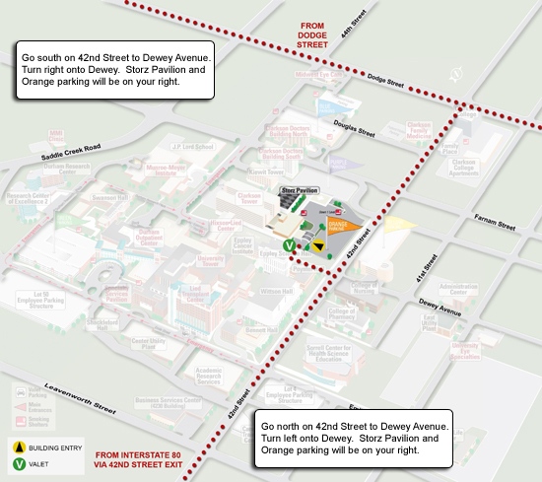

We will be meeting in the Storz Banquet Room #1 and #2. Enter into the main Clarkson Hospital Entrance. Go through the lobby and head North (right) to the Storz Pavillion Restaurant, (you will know you are there because you will see a huge white sculpture). Take the elevator or stairs down to Banquet room 1 & 2.

*We will have MMI staff positioned at the entrance to provide directions. If you get lost, or need additional guidance, please call either Kellie or myself at:
Sarah cell: 402-618-3869
Kellie cell: 402-944-2372

