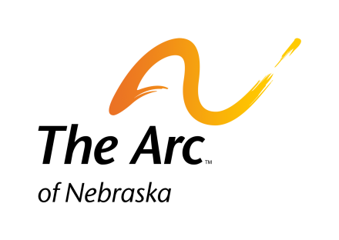 **The Arc of Nebraska’s**

**48th Annual Senatorial Dinner**

**Thursday, February 8, 2018**

**Cornhusker Hotel**

**333 South 13th Street, Lincoln, NE**

10:00-2:00 pm Board of Directors Meeting

1:00-3:00 Legislative Action Day

4:00-6:00 pm Legislative Briefing

5:00 pm Registration

6:00 pm Social Hour

7:00 pm Dinner

**Guest Speaker –** Andy Imparato- Association of University Centers on Disabilities

State Senators will be present to meet with and share personal stories along with your hopes for people with developmental disabilities and their families. We wish to express our appreciation to the Senators for their past and continuing support.

**Please call your Senator and encourage him/her to attend. You may call The Arc of Nebraska for the name and phone number of your Senator. The Arc of Nebraska’s website also has a Legislative link where you may find your Senator’s contact information.**

**-------------------------------------------------------------------------------------------------------------------------------------------**

Name: __________________________________________________ Phone: _________________________________

Address: _____________________________________________ City: _______________________ Zip: ___________

E-Mail: _____________________________________________ Senator: _____________________________________

_____ **Member of The Arc-$40.00**

_____ **Non-Member-$65.00**

_____ I would like to make a contribution for a self advocate’s meal. *(Indicate amount*)

_____I would like to help pay for my Senator’s meal. (*Indicate amount*)

_____ I am unable to attend but would like to make a donation. (*Indicate amount*)

Please mark you meal choice. Meal Includes: coffee, tea, salad and dessert

_____ Pistachio Crusted Salmon with Sweet Chili Sauce with Wild Rice Pilaf, Asparagus, and Carrot

_____Herb Roasted Chicken Breast with Saffron Risotto and Roasted Carrots

_____ Pork Loin with Balsamic Glaze with Mixed Vegetables and Herb Mashed Potatoes

_____ Porcini Truffle Ravioli with White Wine Beurre Blanc Sauce and Roasted Carrots

Special Accommodations (Please Specify) _______________________________________________________

I would like to pay by credit card. Credit Card Number: ______________________________________________________

Security Code _____ Expiration Date: __________________ Total Amount Charged: ______________________________

**Or register on line at:** goo.gl/CBPpa8

***Reservations MUST be made no later than January 28, 2018***

Please Mail or Fax the completed Reservation Form to:

The Arc of Nebraska Phone: 402-475-4407

215 Centennial Mall South, Suite 508 Fax: 888-519-6524

Lincoln, NE 68508 www.arc-nebraska.org